Partial Derivatives and Differentiability Worksheet

- Consider the surface given by the function .
- What is the equation of the curve which is the intersection between and ?

- Find the slope of the tangent line to the curve at the point .

- What is the equation of the curve which is the intersection between and ?

- Find the slope of the tangent line to the curve at the point .

- Determine the signs of the partial derivatives for the function f whose graph is shown below.
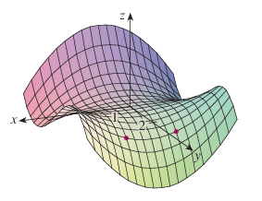

- Find all the first partial derivatives of the function.

- (Hint: Use the Fundamental Theorem of Calculus).

- Find all the second partial derivatives of .

- Find all second partial derivatives of .

- Find given that .

- Find the value of at the point if the equation defines z as a function of the two independent variables x and y and the partial derivative exists.

- Suppose that is determined implicitly by the equation . Find and its value at the point .

- Consider the equation . Find .

- Suppose that for the function we know that and are both differentiable at . Prove that .

